Chapter 8, Solution 80.

t₁ = 1/|s₁| = 0.1x10⁻³ leads to s₁ = –1000/0.1 = –10,000

t₂ = 1/|s₂| = 0.5x10⁻³ leads to s₁ = –2,000

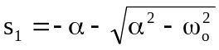

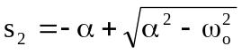

s₁ + s₂ = –2α = –12,000, therefore α = 6,000 = R/(2L)

L = R/12,000 = 50,000/12,000 = 4.167H

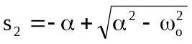 = –2,000

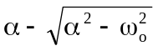 = 2,000

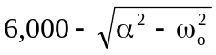 = 2,000

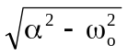 = 4,000

α² – 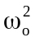 = 16x10⁶

= α² – 16x10⁶ = 36x10⁶ – 16x10⁶

ω_{o} = 10³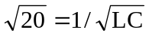

C = 1/(20x10⁶x4.167) = 12 nF

